# SCTR's Pune Institute of Computer Technology Dhankawadi, Pune

**A PROJECT REPORT ON**

Develop a Blockchain based application dApp (de-centralized app) for e-voting system.

# SUBMITTED BY

41121

Manas Milind Deshpande

# Under the guidance of

Prof. U. S. Pawar



DEPARTMENT OF COMPUTER ENGINEERING

Academic Year 2023-24



# DEPARTMENT OF COMPUTER ENGINEERING

**SCTR's Pune Institute of Computer Technology Dhankawadi, Pune**

# Maharashtra 411043

**CERTIFICATE**

This is to certify that the SPPU Curriculum-based Mini Project

Develop a Blockchain based application dApp (de-centralized app) for e-voting system.

# Submitted by

Manas Deshpande

41121

has satisfactorily completed the curriculum-based Mini Project under the guidance of Prof. U. S. Pawar towards the partial fulfillment of the final year

Computer Engineering Semester VII,

Academic Year 2023-24 of Savitribai Phule Pune University.

# Date:

**Place:** PUNE **Name & Sign of Project**

**Guide:**

# Acknowledgment

* It gives me great pleasure to present the mini project on - Develop a Blockchain based application dApp (de-centralized app) for e-voting system.

First of all, I would like to take this opportunity to thank my guide Prof. U. S. Pawar for giving me all the help and guidance needed. I am grateful for his kind support and valuable suggestions that proved to be beneficial in the overall completion of this project.

I am thankful to our Head of the Computer Engineering Department, Dr. G. V. Kale, for her indispensable support and suggestions throughout the internship work. I would also genuinely like to express my gratitude to the CC, Prof. Samadhan Jadhav, for his constant guidance.

Finally, I would like to thank my mentor, Prof. U. S. Pawar for his constant help and support during the overall process.

# Title:

- Develop a blockchain based App.

# Problem Statment:

Develop a Blockchain based application dApp (de-centralized app) for e-voting system

# Objective:

* To develop blockchain based App
* To build an decentralized app(Dapp) for e-voting system.

# Theory :

**Introduction:**

E-voting systems leverage blockchain technology to introduce a secure, transparent, and tamper-proof method for conducting elections. Traditional voting systems are susceptible to various challenges, such as voter fraud, manipulation, and lack of transparency. By utilizing Ethereum, a decentralized platform, we can create an e-voting system that ensures the integrity of the voting process and enhances trust among participants.

Objective: The objective of this project is to design and implement a decentralized e-voting system using Ethereum smart contracts. The system allows eligible voters to cast their votes securely and transparently. It provides an interface for voters to interact with the Ethereum blockchain, ensuring the integrity of the electoral process.

**Key Features:**

Transparency: All voting records are stored on the Ethereum blockchain, providing a transparent and publicly auditable ledger of votes.

Security: The use of blockchain technology ensures the security of votes, making it extremely difficult for malicious actors to alter or manipulate the voting data.

Accessibility: Voters can cast their votes remotely using a user-friendly interface, promoting accessibility and convenience.

Immutability: Once a vote is recorded on the blockchain, it cannot be changed or deleted, ensuring the integrity of the electoral history.

Components:

Smart Contracts: Ethereum smart contracts define the rules and logic of the e-voting system. They handle the storage of voter information, candidate details, and the voting process itself.

User Interface: A user-friendly web interface allows voters to interact with the smart contracts. It includes functionalities for voter authentication, candidate selection, and casting votes.

Blockchain Network: The Ethereum blockchain network serves as the underlying infrastructure for the e-voting system. It records all transactions and ensures consensus among network participants.

**Implementation:**

Smart Contracts: Solidity programming language is used to implement the smart contracts. These contracts define the structure of the voting system, including functions for voter registration, vote casting, and result retrieval.

Frontend Development: HTML, CSS, and JavaScript are employed to create a web-based interface for voters. Web3.js library facilitates the interaction between the frontend and the Ethereum blockchain.

**Security Considerations:**

Authentication: Proper authentication mechanisms are implemented to verify the identity of voters before they can cast their votes.

Gas Limit: Smart contract functions are optimized to handle gas limits efficiently, ensuring that transactions are processed without running out of gas.

Private Key Management: Voters are educated about securely managing their private keys to prevent unauthorized access and voting on their behalf.

# Results:

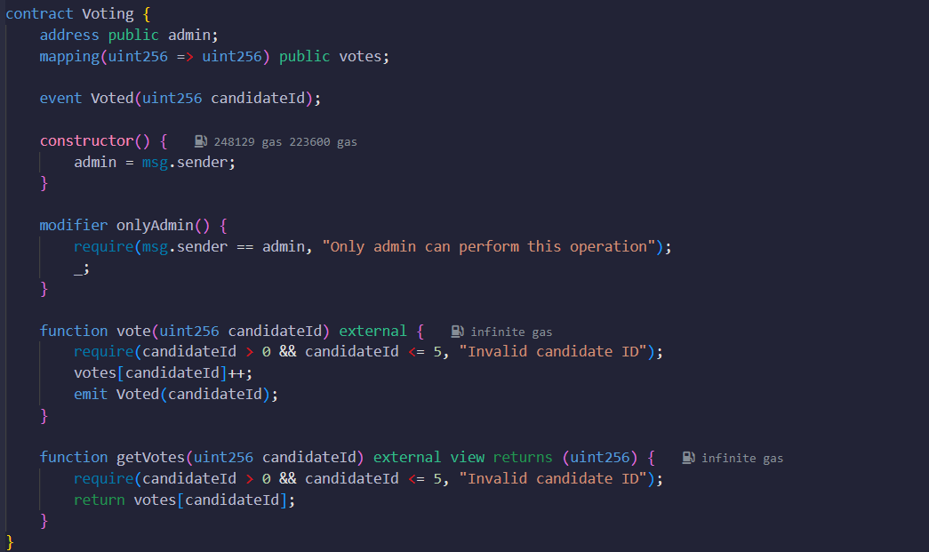

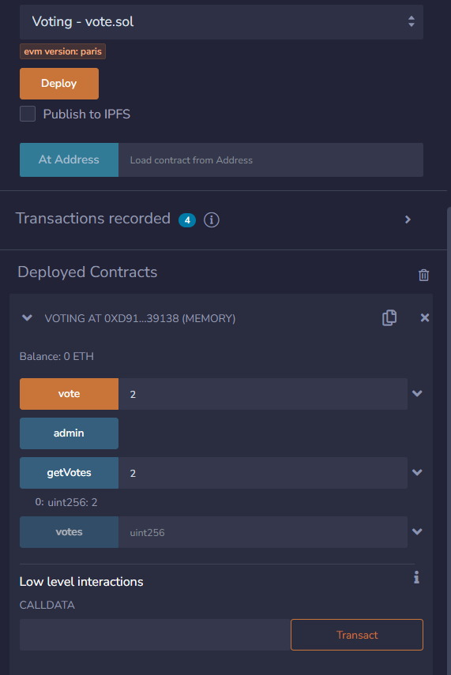

**Conclusion :**

The Ethereum-based e-voting system provides an innovative solution to the challenges faced by traditional voting systems. By leveraging the principles of blockchain technology, it ensures transparency, security, and accessibility, fostering trust in the electoral process. However, continuous testing, security audits, and user education are essential to the successful deployment and adoption of such a system.

Top of Form

.